Charlotte County PUblic Schools
January 2022 Menu

Monday | Tuesday | Wednesday | Thursday | Friday | 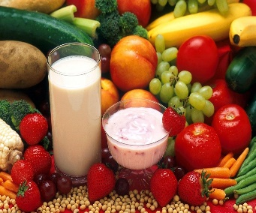
Breakfast Menu for the Month
Each breakfast comes with Milk & 100% Fruit Juice
Mini Pancakes w/syrup | Chicken Biscuit | Breakfast Pizza | Sausage Biscuit or Egg & Cheese Biscuit | Donut or Cereal
Lunch Menu
3  School Closed | 4  School Closed | 5 Corn Dog Nuggets  Sides  Baked Beans  Cup Diced Pears | 6 BBQ Chicken w/Roll  Sides  Mashed Potatoes  Peaches | 7 Cheeseburger on Bun  Sides  Broccoli w/Cheese  Mixed Fruit Cup | Please stay current with your student’s cafeteria account by paying ahead. Check balance and make payment at K12PaymentCenter.com  In our efforts to provide tasty, fresh and healthy meals, we may make changes to the menu at the Chef’s discretion or food availability.  USDA is an equal opportunity provider and employer.
10 Chicken Nuggets/Roll  Sides  French Fries  Mixed Fruit Cup | 11 Big Daddy’s Cheese Pizza  Sides  Baby Carrots  Fresh Banana | 12 Beef Taco Meat w/Nacho Chips  Sides  Corn  Peaches | 13 Grilled Cheese  Sides  Vegetable Soup  Strawberry Cup | 14 Popcorn Chicken w/Egg Roll  Sides  Broccoli w/Cheese  Applesauce Cup
17  School Closed | 18 Oven Fried Chicken w/Roll  Sides  Mashed Potatoes  Cup Diced Pears | 19 Chicken Nuggets/Roll  Sides  Baked Beans  Cup Diced Pears | 20 Big Daddy’s Pepperoni Pizza  Sides  Green Beans  Mixed Fruit Cup | 21 Chicken Filet on Bun  Sides  Steamed Carrots  Applesauce Cup
24 Big Daddy’s Cheese Pizza  Sides  Baby Carrots  Fresh Banana | 25 Rotisserie Chicken w/Roll  Sides  Mashed Potatoes  Cup Diced Pears | 26 Grilled Cheese  Sides  Vegetable Soup  Strawberry Cup | 27 Chicken Alfredo w/Bread Stick  Sides  Broccoli w/Cheese  Applesauce Cup | 28 Cheeseburger on Bun  Sides  Baked Beans  Fresh Grapes
31 Asian Chicken Chunks w/Vegetable Rice
Sides
Steamed Broccoli
Mandarin Oranges

